*Computer networks practical experiments*

**EXPERIMENT NO—1::**

*Aim :* **configuring networks devices using packet racer.**

***Requirments:***

**1.switch/hub-interferecnce btwn two devices.**

**2.end devices-they are the devices through which we can pass msg from one end to other.**

**3.cable-for connection.**

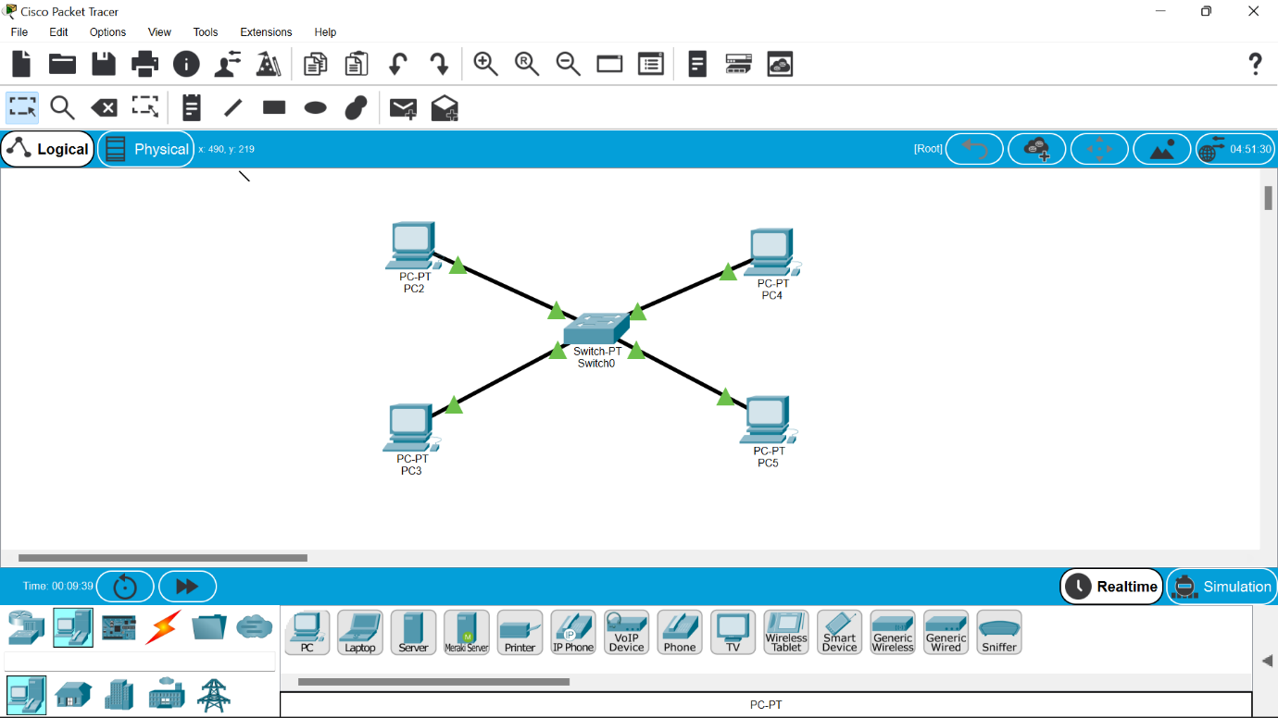

**Four systems are connected to switch using**

**Straight through cable.**

**Ip address will be provided to each system.**

***Procedure:***

**1.The main aim is to configure btwn network devices.**

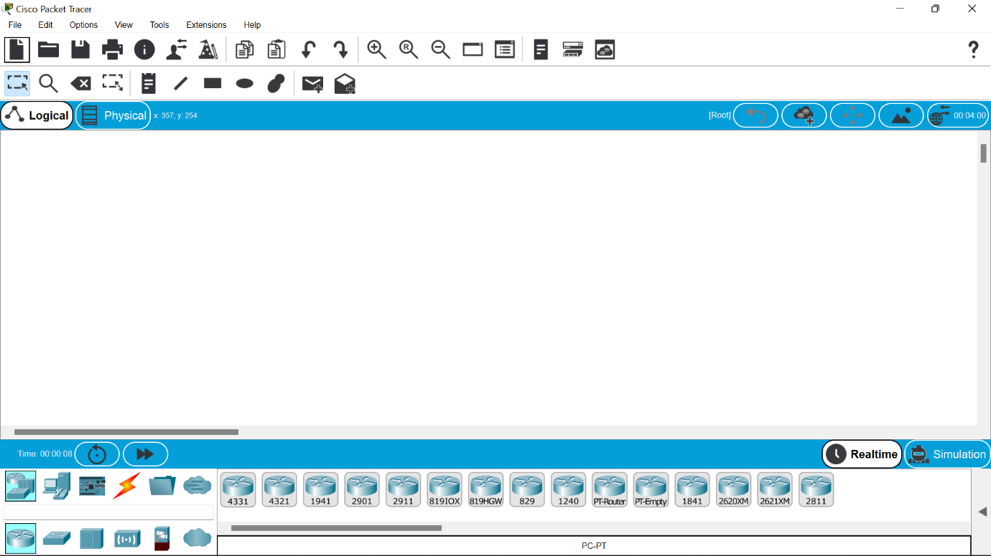

**2.the concept involved in this is ip addressing and address resolution protocol(arp).**

**3.click on the end devices and select pc and drag and drop on the window .**

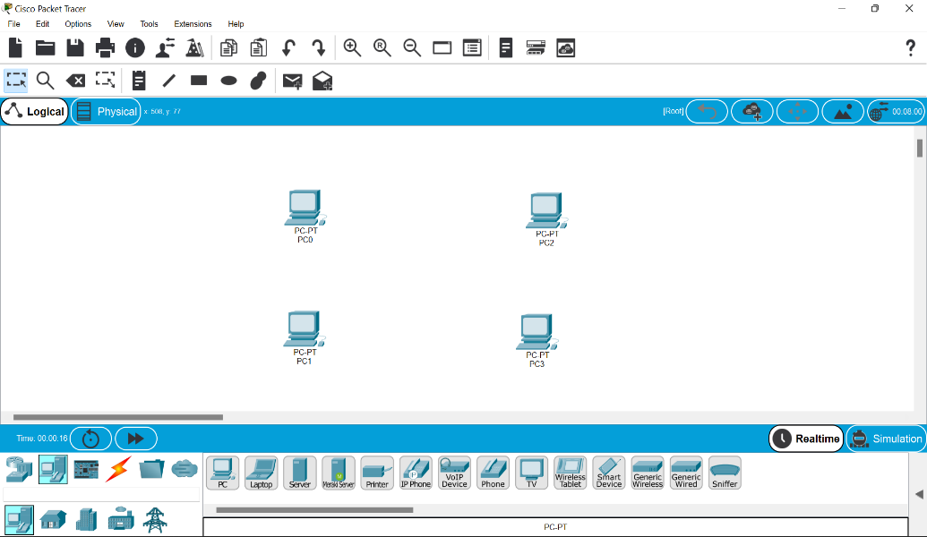

**4.select the switch and drag it and drop it .**

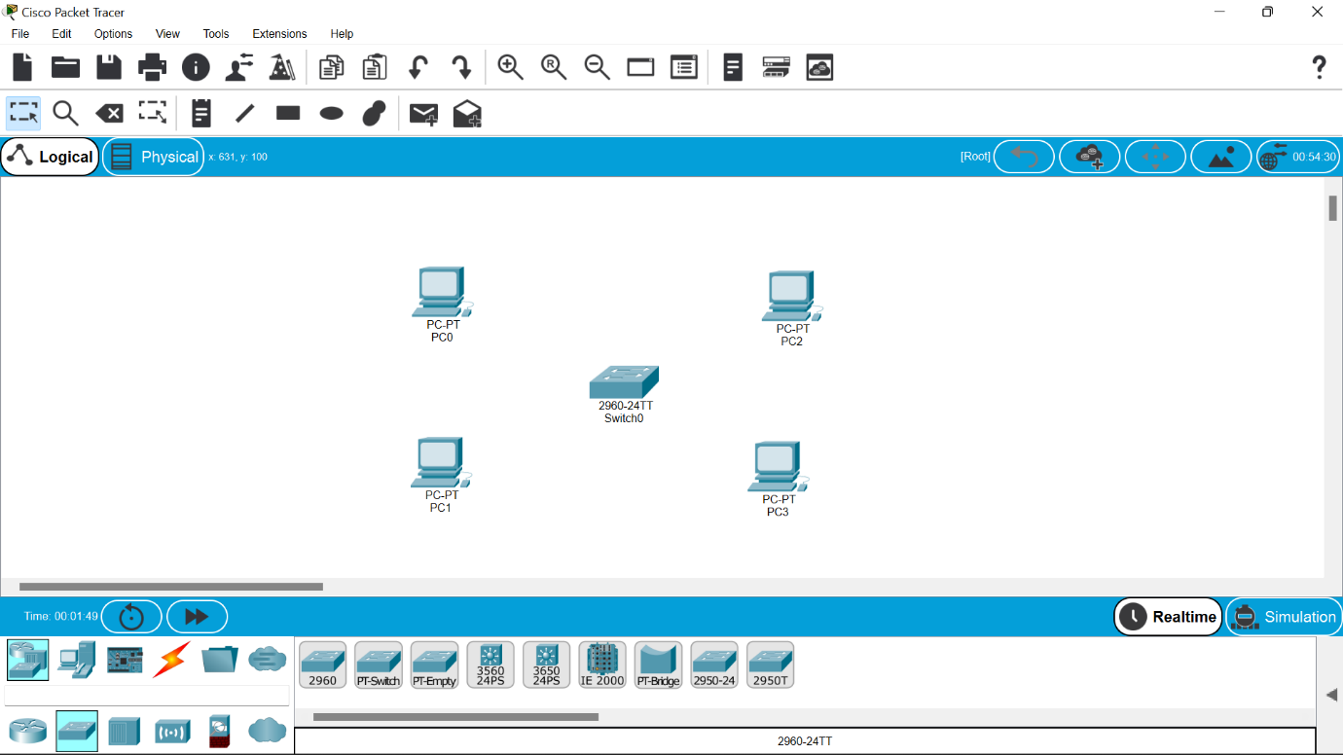

**5.select the straight line through cable and collect all the end devices to switch .**



**6.assign ip address to all the devices .**

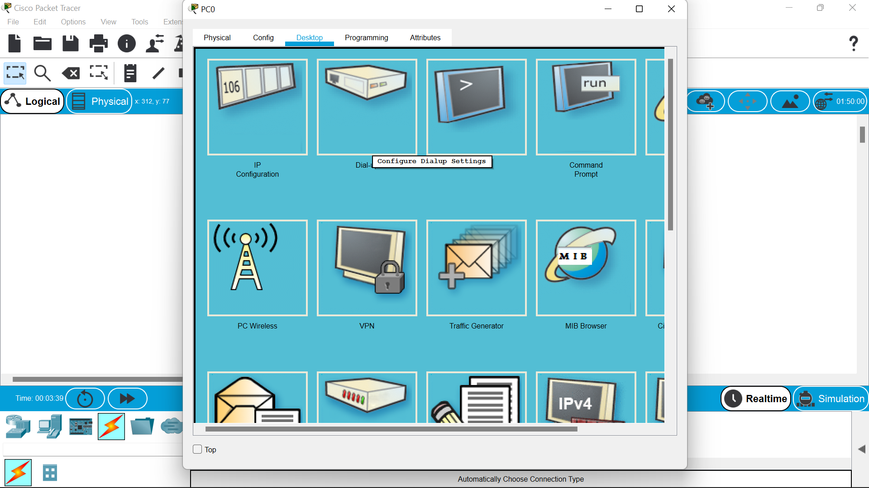

**7.to view the ip address we can go to command prompt and type ipconfigure for each particular.**

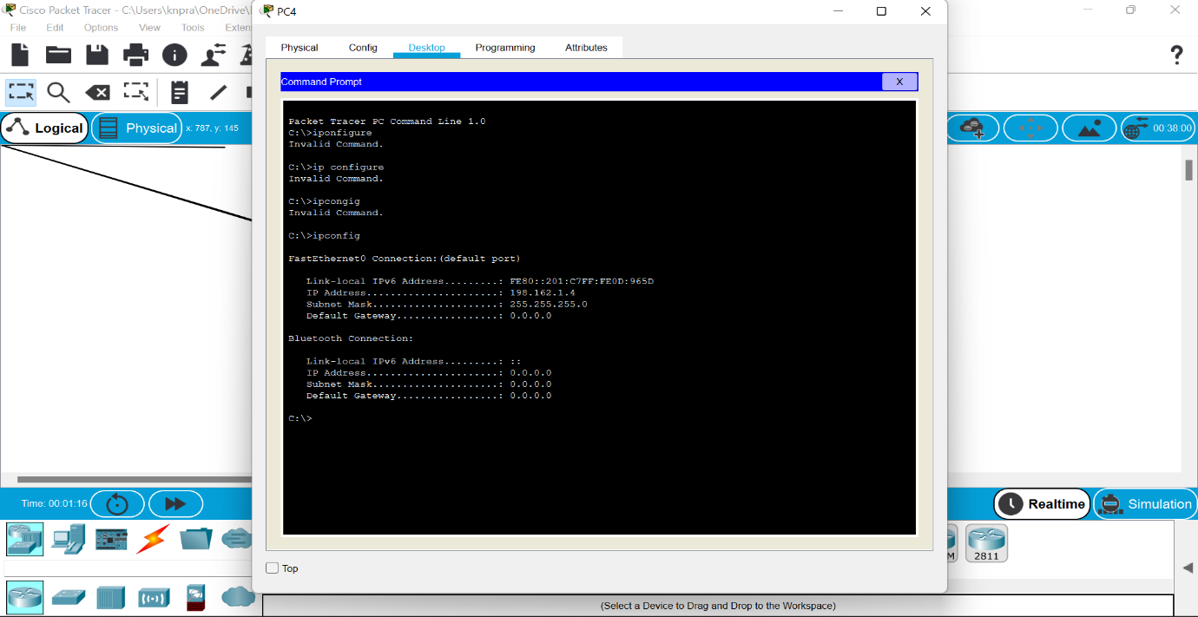

**8.we can also ping command to view the connections btwn devices.**

***Result:***

***Thus the establishment of configuration btwn network device has been done successfully.***